***SOFTWARE DESIGN DOCUMENT***

**1.0 Introduction**

The purpose of this document is to specify the requirements and preview some elements of the analysis model of the website. This software will be used to further generate us in the business aspect of our lives.

This website consists of simple html code to provide better services to our clients in the community

**1.1 Goals and objectives**

Our main goal for this website is to have an organized system of workorders and comments to provide outstanding customer service

**1.2 Statement of scope**

This website offers a complete and easy way to create and organize different sets of customer work orders categorizing them with flags or by groups them in an appropriate way to make repairs to clients hardware/software needs. The benefits of this are the client will receive a speedy and knowledgeable interaction with a employee providing suitable and satisfactory business.

Its main objective is to setup an remote connection test environment that allows users like clients to have one on one connection to make fixes from home.

The goal is to make possible to clients a fast easy and affordable way to get their computers repairs

**1.3 Software context**

**Developer**: The developer who wants to read, change, modify or add new requirements in to the existing website, must firstly consult this document and update the requirements with appropriate manner so as to not destroy the actual meaning of them and pass the information correctly to the next phases of the development process.

**User**: The user of this program reviews the diagrams and the specifications presented in this document and determines if the software has all the suitable requirements and if the software developer has implemented all of them.

**Tester**: The tester needs this document to validate that the initial requirements of this website actually corresponds to the document and features correctly.

.

**1.4 Major constraints**

This website is created using Html programming language and uses the PC having at least 8mb of RAM and CPU over 3.00 Ghz is required to run the website with good speed.Also requires the server computer to be on and running.

**2.1.1 Screen images**

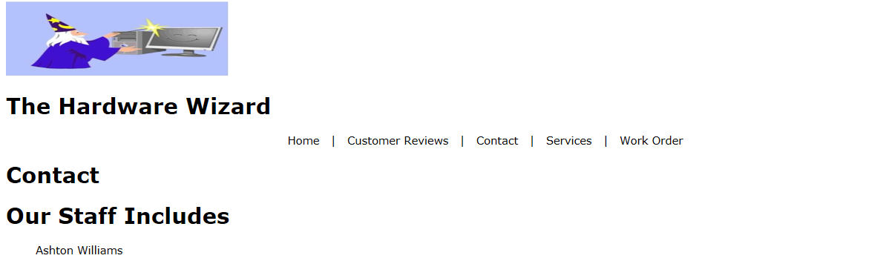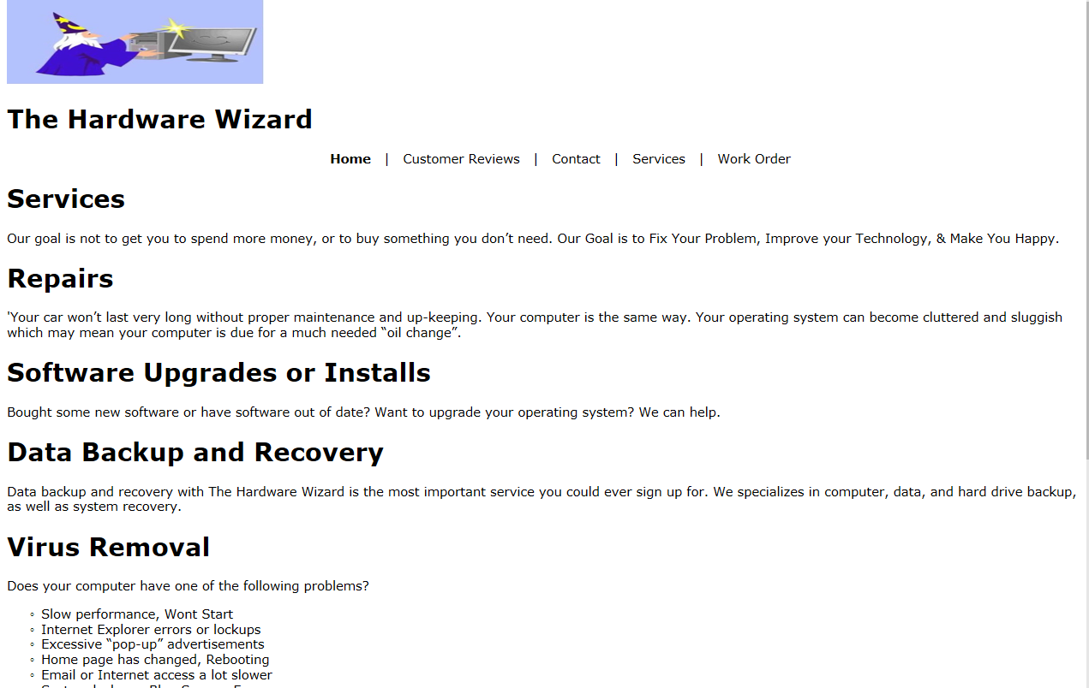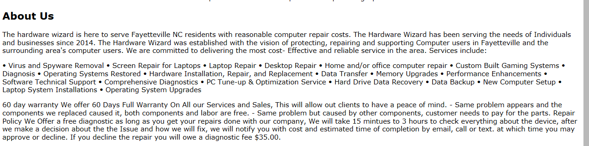**2.1.2 Objects and actions**

Picture one shows our tab layout of our website picture two shows what we want to have for our services and features and finally the third picture shows a little information about us

.

**3.0 Testing Issues**

As of right now the only issue we have found is that our customer review tab is not working correctly

**4.0 Appendices**

none

DD Template